FreeETarget
Application Note: 50 Meter Pistol Target

CAUTION

When using freeTarget:

- Wear eye protection
- Maintain a safe distance
- Do not shoot into any areas except the open target areas.

The freeETarget project or contributors will not be responsible for any injuries when using this target of it’s components.

Target shooting can be dangerous so apply caution in everything you do.

SUMMARY

freeETarget can be used as a 50 meter pistol target with the same hardware as the conventional 10 meter target. The differences being the use of a semi-ridgid backing material and setting the sensors for the larger paper.

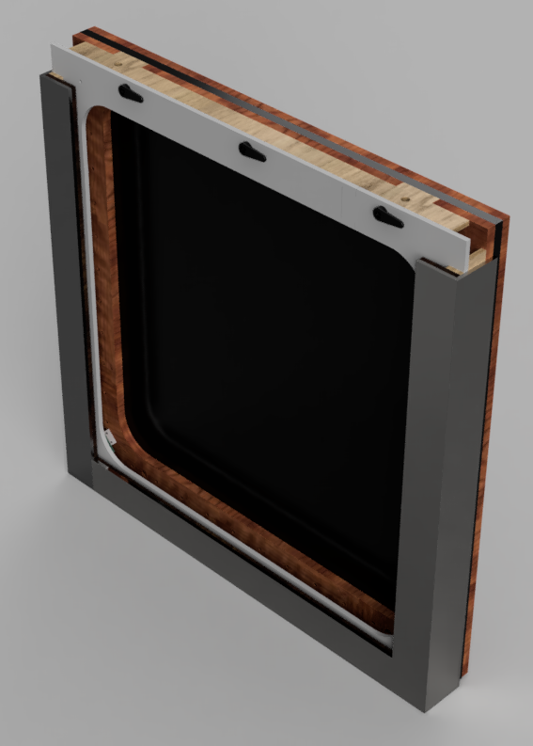 | 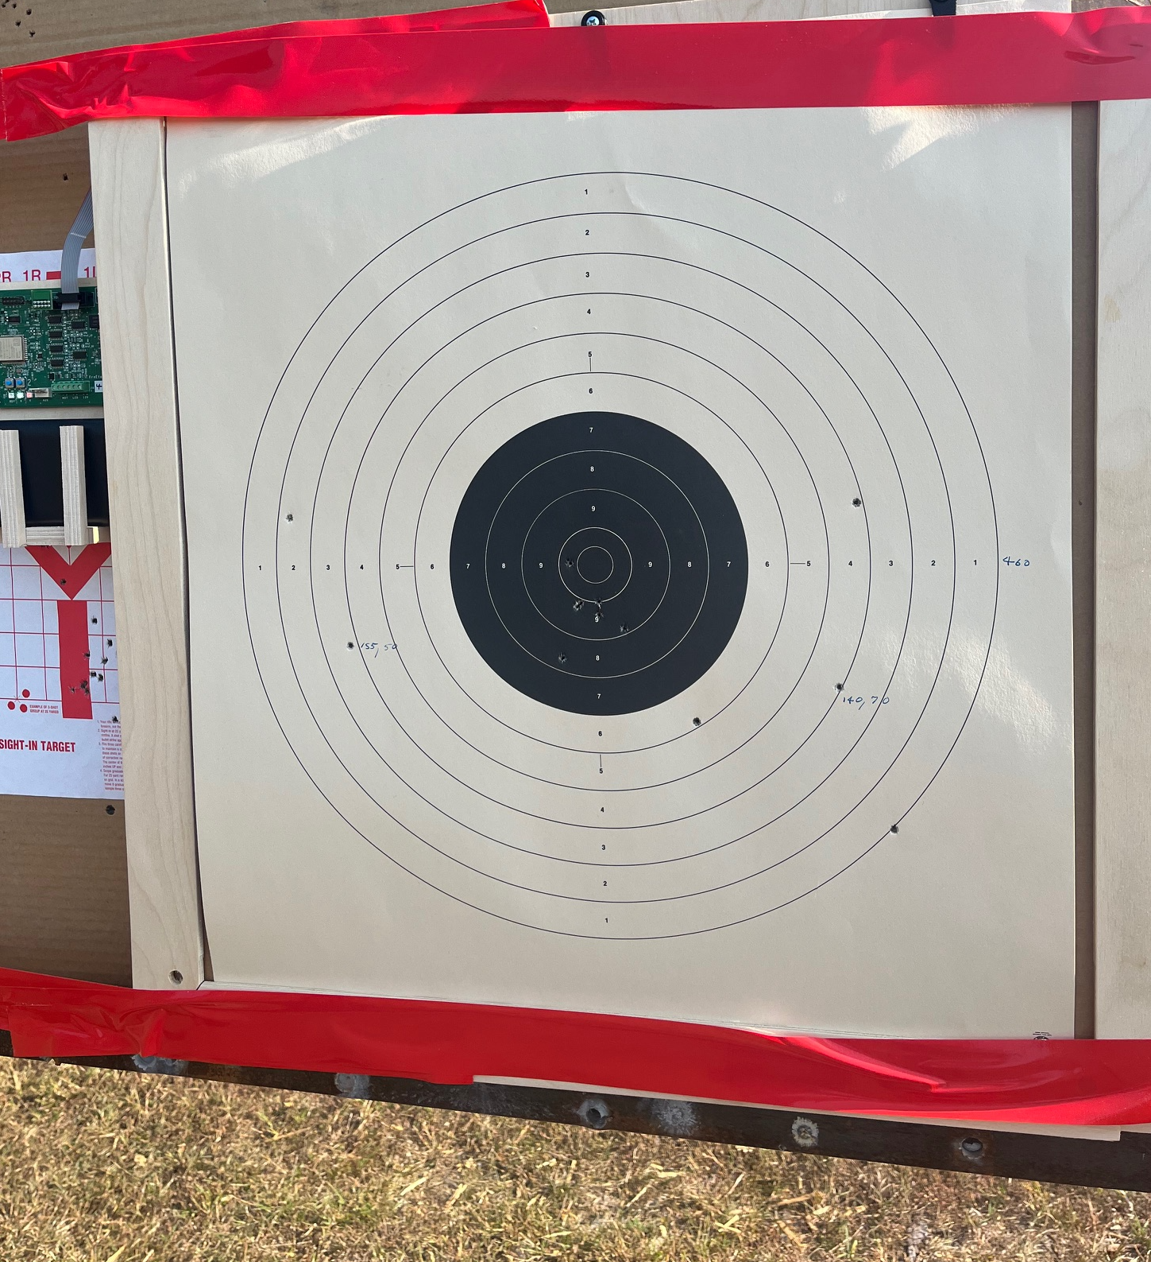

Figure 1” 50 Meter Pistol Target

CONSTRUCTION
Construction follows the same process as a simple 10 meter air target. The differences are:
- Larger 778 mm sensor spacing
- No lights or witness paper
- Heavy rubber mat before the bullet trap
The target is constructed by laminating a series of items together. The construction is shown in Figure 2 and itemized in Table

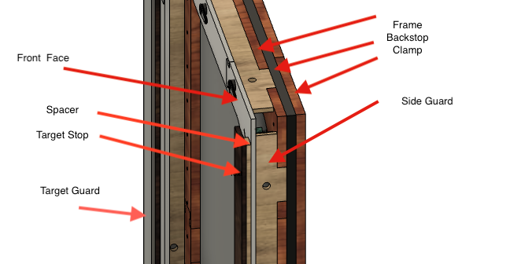
Figure 2: Target Build Up

Table 1: Target Components

Item | Description | Material
Frame | Rectangular frame to assemble target | ½” Plywood
Backstop | Rubber mat to sound projectile | ¼” Neoprene truck liner
Clamp | Rectangular frame to hold backstop | ½ Plywood
Sensor Mount | Plywood sensor mount (not shown) | ½” Plywood
Sensor | Electronic circuit (not shown)
Sie Guard | Prevent debris from getting to sensors | ¼” Plywood
Front Face | Rectangular frame to hold target in place | ¼” Plywood
Spacer | Strip of material spce cardboard backer | ¼” Plywood
Target Stop | Strip of material to hold target in place | ¼” Plywood
Target Guard | 1/8” Steel L bracket to protect from shots | 2”x2”x1/8 Steel L bracket

Start by construction a target frame large enough to support the target. The frame illustrated in Figure 3 is 650 mm x 650mm ½” plywood. To save on wood and fit into a small workshop, the frame is made from four hocky-stick segments
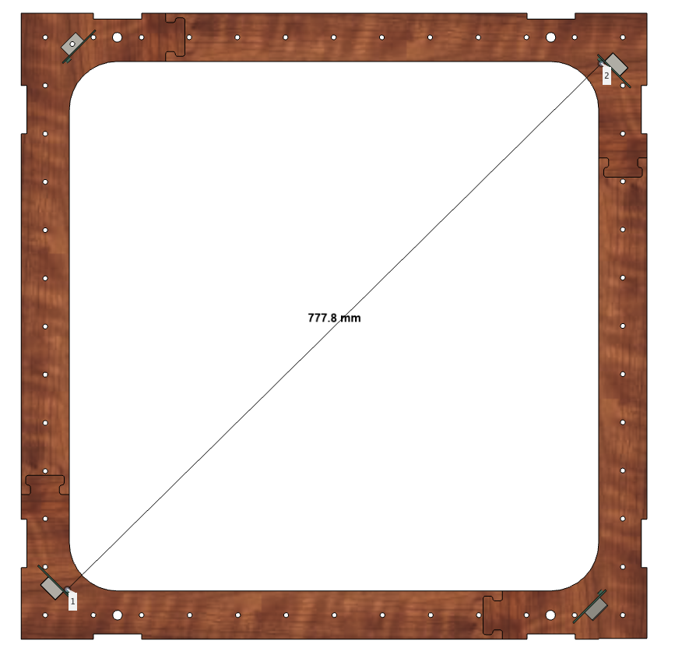
Figure 3: Sensor Location
Build the clamp using the same construction as the frame. If you made the frame from four segments as shown in Figure 3, reverse the segments to that the joints don’t line up.

Locate the rubber backstop between the frame and clamp. Drill 5mm holes between the frame and clamp, through the rubber every 50mm. Use 5x40mm bolts from the front to the back and tighten with nuts. When finished the target will be a ridged frame

Attach the sensors and cables to the sensor mount as shown in Figure 4

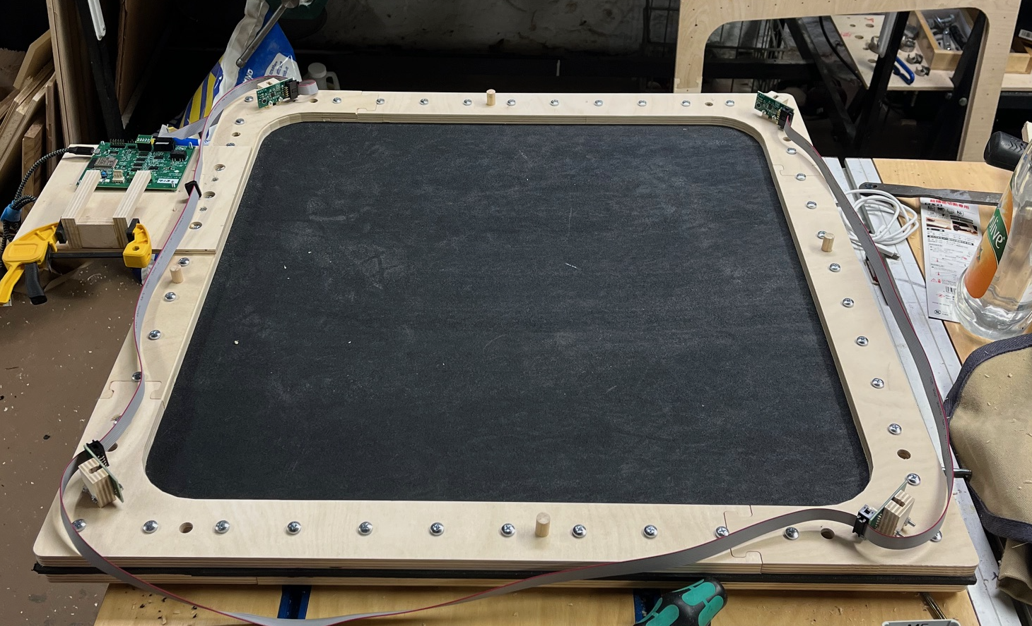
Figure 4: Sensor Assembly

Build the front face using ¼” plywood similar to the frame. As shown in Figure 5

Align the front face to the frame and drill 5mm holes through the sensor mounts

Attach the front face to the frame using long 5mm bolts

Glue the spacer strips to the front face.

Glue the target stop to the spacers

Connect the circuit board to the cable harness

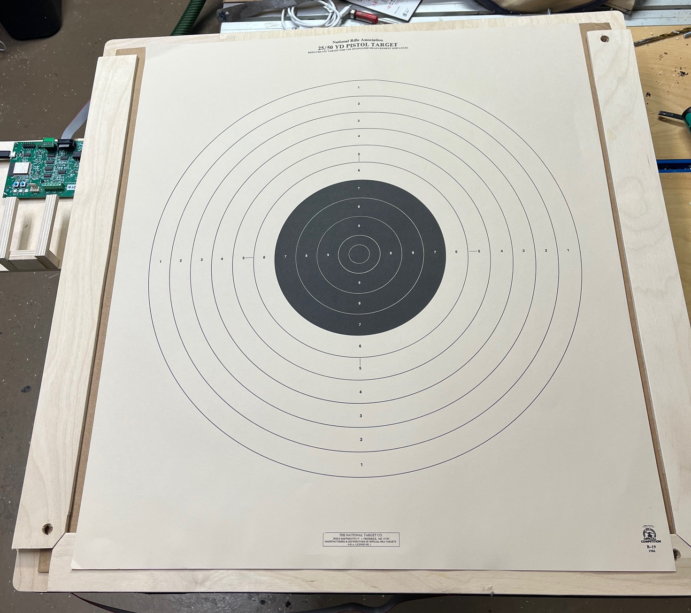
Figure 5: Final Assembly

CONFIGURATION

The 50 meter pistol target operates the same way as an air pistol target except:
- Larger sensor diameter
- No witness paper
The configuration used for this is:

{“SENSOR”:778, “PAPER_TIME”: 0}

OTHER

Noise Filtering

Depending on the ambient noise at your range, you may need to increase the trip point to mask other shots. Start with

{“VREF_LO”:1.5, “VREF_HI”:2.25}

Useable values for VREF_LO range from 1.25 to 4.25 volts
VREF_HI must always be larger than VREF_LO, +.0.5V

You may need to experiment with different values for your needs.

Shot Accuracy

Depending on conditions, your shot accuracy may improve by

{“PCNT_LATENCY”:31}

This enables the second set of timers to.be used to improve detection of the origin of the sound signal.

This feature can be disabled by

{“PCNT_LATENCY”:0}

